
SUPPLY CHAIN MANAGEMENT

Telephone 031 566 0490 Fax 086 606 2614 email: nkosi@shark.co.za

REQUEST FOR QUOTATION (RFQ)

ENQUIRIES: MR Nkosingiphile Mathebula

To:

Tel:

Email:

Attention:

You are hereby invited to a submit quotation for the supply and delivery of the following item/ service to the KZN Sharks Board (KZNSB).
Item | Description | Qty
01. | Please quote, complete and sign the attached standard bidding documents | See attached Specification
02. | Submit Original and valid Tax Clearance Certificate
03. | Submit Original or copy BEE Certificate (certified copy)
04. | Proof of Treasury Central Supplier Database registration and Supplier number
05. | Bank letter not older than 3 months
06. | SBD6.2 For local production and content
CLOSING DATE: 25/01/2019 CLOSING TIME: 11:00

Please submit your quotation on the Organisation’s quotation form attached hereunder, and clearly indicate the delivery period and validity period of your quotation. Please also clearly indicate whether your price includes or excludes VAT. (You may claim VAT only if you are a VAT vendor, please provide VAT NUMBER.)
This service is required at 1a Herrwood Drive, Umhlanga Rocks (DELIVERY ADDRESS) on the____ _______DELIVERY DATE

TERMS AND CONDITIONS:

- If a Supplier fails to deliver any or all goods, or a service provider fails to perform the required services within the period specified in the Order/Contract, the KZNSB may as a penalty deduct from the Order/Contract price a sum of the delayed goods or unperformed services or terminate the contract in part or in whole.
- The Organisation’s quotation form must be completed in detail, signed by the bidder and bear the signature of witnesses, and be forwarded to the KwaZulu Natal Sharks Board CFO Division. Failure to comply with these requirements may result in the quotation being disregarded.

Yours faithfull
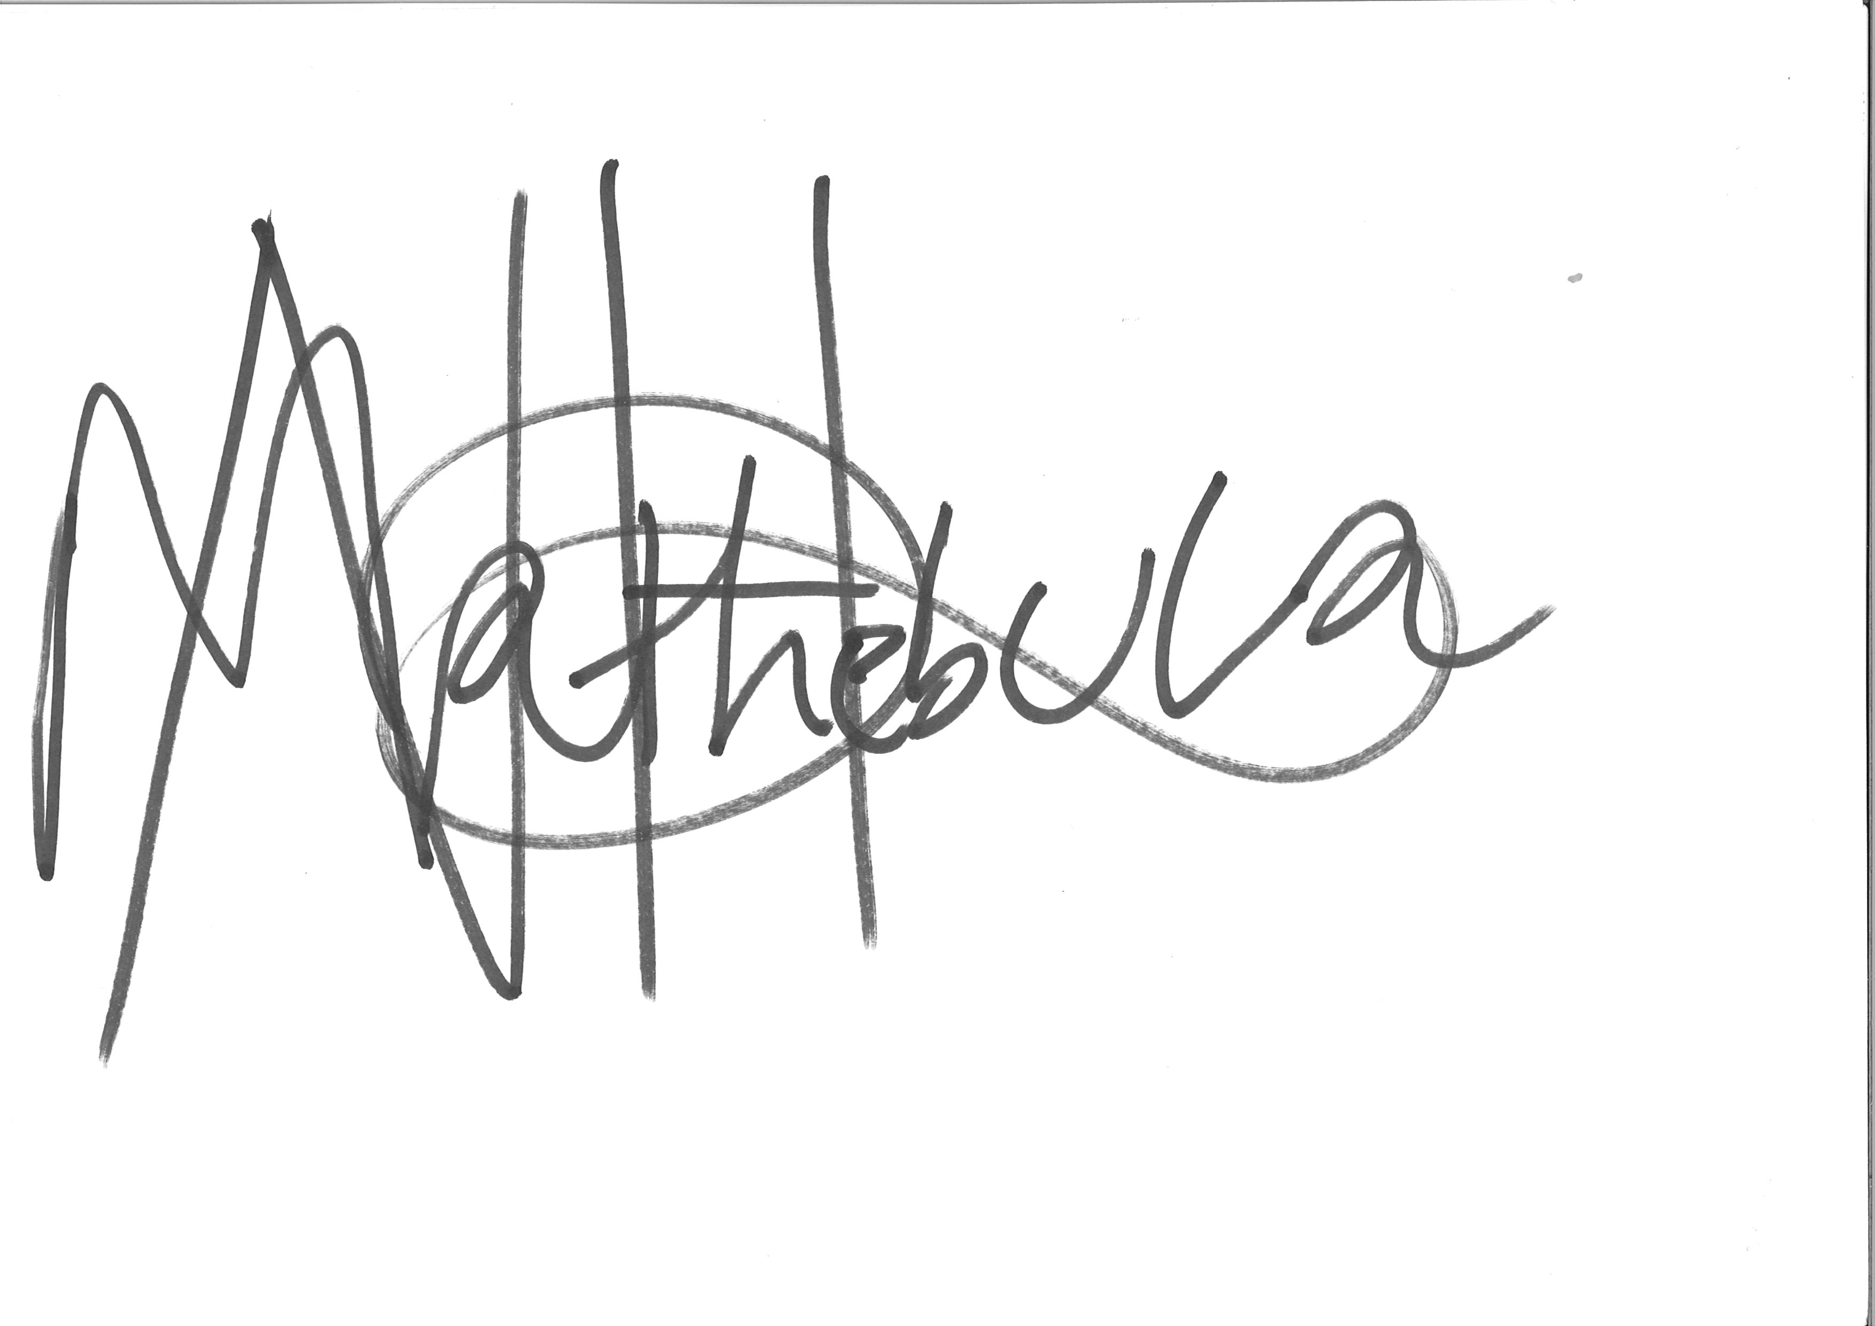
NAME: Mathebula N_________________________________ SIGNATURE: DATE: 22/01/2019

- ITEM REQUIRED: QUOTATION ENQUIRY NO: 2738ZNQFIN-18

DESCRITIO | QUANTITY | UNIT PRICE | TOTAL PRICE
Floats Drumline FL/510/H Red | 80
Total

- The bidder must be registered with Treasury Central Supplier Database. (CSD)
- The bidder must provide original Tax Clearance Certificate, unless the KwaZulu – Natal Sharks Board is in possession of a valid one.
3.1 Bidders / service providers are required to submit together with their bids / quotations an original and valid B-BBEE Status Level Verification Certificates or certified copies thereof to substantiate their B-BBEE rating claims. B-BBEE Verification certificates are valid only if issued by a verification agency accredited by either SANNAS and / or IRBA
3.2 In terms of the Generic Code of Good Practice, an enterprise with annual total revenue of R5 million or less qualifies as an Emerging Micro Enterprise. EMEs are deemed to have a B-BBEE status of “level four (4) contributor”. Evidence of such qualification must be a certificate issued by a registered Auditor, Accounting Officer as defined in Section 60(4) of the Close Corporation Act No 69 of 1984 or an accredited verification agency.
3.3 A verification certificate is only valid for 12 months.
4. The bidder quotation should clearly indicate the validity period.
5. Quotations must be fully completed in all respect and it is strictly essential.
6. Please confirm that your banking details are still the same. If these have changed, please submit a new application form with a bank stamp.
7. Practice note for Financial Management No. 3 of 2006 (Amendment 4 of 2010) Paragraph 3.2 (b) & (c)
- The Accounting Officer/ Authority must settle all payments due to creditors within 30 days from receipts of an invoice unless determined otherwise in a contract or other agreement.
- The Accounting Officer/ Authority must make no payments no earlier than necessary, avoid prepayments for goods and services unless required by contractual arrangements and accept discounts to effect early payments.
8. Quotations are to be evaluated in accordance with new Preferential Procurement Policy frame works that are promulgated by National Treasury and KwaZulu – Natal Provincial Treasury.
9. The 80/20 preference point system to be used for all procurement up to a R 100 000 000.00 (VAT included

NB: Please provide the CSD supplier number which is on the Treasury letter head. Failure to comply you will be automatically be disqualified.

NB: Please confirm the availability of stock and the delivery date when submitting the quotation.

SUB TOTAL…………………………………………

VAT…………………………………………………….

TOTAL……………………………………………………..

Name of Company……………………………………………………………………………………………..

Authorized Signature…………………………………………………………………………………………..

Name of Representative……………………………………………………………………………………….

Designation……………………………………………………………………………………………………….
COMPANY STAMP

Date………………………………

KZNSB NO……………………………..

