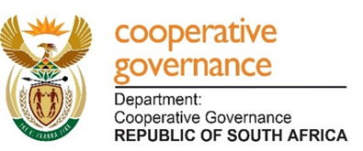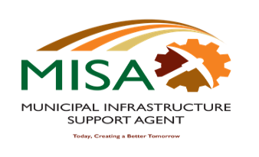

MUNICIPAL INFRASTRUCTURE SUPPORT AGENT
Letaba House, Riverside Office Park, 1303 Heuwel Avenue, Centurion, 0046
Private Bag X105, Centurion, 0046 Tel: 012-848 5300

LIST OF 22 PRIORITY MUNICIPALITIES

No. | Province: Eastern Cape
1 | Amathole District Municipality
2 | Enoch Mgijima Local Municipality

No. | Province: Free State
3 | Maluti-a-Phofung Local Municipality
4 | Metsimaholo Local Municipality

No. | Province: KZN
5 | Mpofana Local Municipality
6 | Msunduzi Local Municipality
7 | Uthukela District Municipality
8 | Umzinyathi District Municipality
9 | Abaqulusi Local Municipality
10 | Umkhanyakude District Municipality

No. | Province: Limpopo
11 | Mogalakwena Local Municipality

No. | Province: Mpumalanga
12 | Msukaligwa Local Municipality
13 | Govan Mbeki Local Municipality
14 | Thaba Chweu Local Municipality

No. | Province: Northwest
15 | Madibeng Local Municipality
16 | Kgetlengrivier Local Municipality
17 | Tswaing Local Municipality
18 | Mafikeng Local Municipality
19 | Ditsobotla Local Municipality
20 | Ramotshere Moiloa Local Municipality
21 | Dr Ruth Segomotsi Mompati District Municipality

No. | Province: Western Cape
22 | Kannaland Local Municipality

